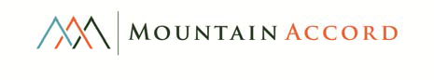
COTTONWOOD TASKFORCE RECOMMENDATION

For Executive Board and Public Review

Summary: Mountain Accord is a regional decision making process to address issues of environmental protection, recreation, economic prosperity, and transportation. The alternative to the Mountain Accord process is the status quo – continued conflicts over proposals for land protection and development, and increasing challenges for natural resource protection and management capability. Through Mountain Accord, a diverse group of government, environmental, recreation, transportation, and commercial interests seek to achieve a deliberate, long‐term vision
for the Central Wasatch Mountains that will protect the primary source of the region’s water supply, resolve increasingly intractable transportation and safety issues associated with moving people to recreation areas in the Wasatch, and establish a balance for recreation users in increasingly competed‐for high mountain terrain.

Issues in Big and Little Cottonwood Canyons represent critical considerations within those contexts. The two canyons have been the subject of persistent concern with regard to environmental protection, water resource protection, ski area development, and dispersed recreation use. The Mountain Accord Executive Board asked a group of the leading parties in upper Big and Little Cottonwood Canyons to take the work of the Mountain Accord Systems Groups and agree on a proposal that addresses the issues and conflicts facing these two canyons.

The Cottonwood Canyons Task Force (CCTF), with representatives of local and federal government jurisdictions, environmental and backcountry recreation interests, and the four Cottonwood Canyon Ski Areas, has agreed on a recommendation that addresses environmental protection, water resource protection, recreation conflicts, land preservation, land ownership adjustments, Ski Area prosperity, and the best transportation mode that serves those objectives. Parties agreed that broad land preservation and transfer of private lands to public ownership, combined with Ski Area enhancements and a rail system with tunnels, would best fulfill several Mountain Accord objectives, including:

• Water resource protection
• Preservation of lands for environmental values, including watershed protection, wildlife habitat, ecosystem health, and aesthetics
• Preservation of lands that offer unique recreation experiences and access
• Prioritization of preservation of lands that are contiguous to other open space
• Reduction of checkerboard USFS property ownership pattern (i.e., secure inholdings)
• Consolidation of Ski Area ownership at the base of the ski resorts

Some details of this recommendation, such as the specific amount of water and number of units or development in base areas, would need to be finalized with further analysis, and after public input on the concepts presented.

Recommendation: All parties of the CCTF (Alta, Brighton, Snowbird, Solitude, Outdoor Industry, Save our Canyons, SLC, SLCO, USFS, Town of Alta), in the context of a rail system connecting the Wasatch Front to the ski areas in Salt Lake County via Little Cottonwood Canyon and a tunnel to Big Cottonwood Canyon, recommend the program of land use summarized below, and detailed in the table that follows:

1. Salt Lake City , Salt Lake County, and the USFS receive, and the public benefits from, permanent protection of land parcels throughout the
Wasatch Mountains (Figure 1) to protect water and environmental resources through:
a. Widespread land and municipal watershed conservation throughout the Mountain Accord project area, b. Additional protective federal lands designations throughout the Mountain Accord project area,
c. Tools and resources to manage the health and well‐being of the municipal watersheds into the future.
2. The public receives certainty that threatened backcountry and dispersed recreation areas adjacent to the existing Cottonwood Canyons ski resort boundaries are preserved in perpetuity for backcountry use and environmental protection.
3. The public receives approximately 2,150 acres of land currently owned by the Ski Areas and adjacent to existing ski resort boundaries for permanent year‐round backcountry, watershed, and environmental protection, including properties in the Superior, Flagstaff, Grizzly Gulch (under consideration), White Pine, upper Big Cottonwood Canyon, Cardiff, and other areas. The public receives certainty that the Ski Areas will not seek further expansions in Big and Little Cottonwood Canyons with the minor exceptions outlined in item 4c below.
4. The Ski Areas receive:
a. Approximately 288 acres of land from the USFS for base‐area management and future development to support activity at transit stops,
b. Approximately 416 acres from the USFS in American Fork Canyon, subject to American Fork/Utah County planning and public involvement.
c. Limited permit boundary expansions totaling approximately 210 acres (approximately 140 acres in Hidden Canyon, 70 acres in lower
Silver Fork adjacent to Honeycomb Canyon)
d. Additional limited water for snowmaking and station‐area development purposes from Salt Lake City, which may include geographically‐confined development activity.

5. Additionally, the CCTF would support a tunnel connection to Park City/Summit County, while also recognizing and respecting the decisionmaking jurisdiction of those entities; adding the Park City connection from Big Cottonwood Canyon would not adversely alter these negotiated recommendations.

County

\ tl
'?
(
r

fop of Great estern
* I
I

.,. - I
I

h
Snowbird Cou

I
,J
)

* white Pine

I
I
\
\
\
\
\
\
\
\
\
1-. ....
\
I,
/
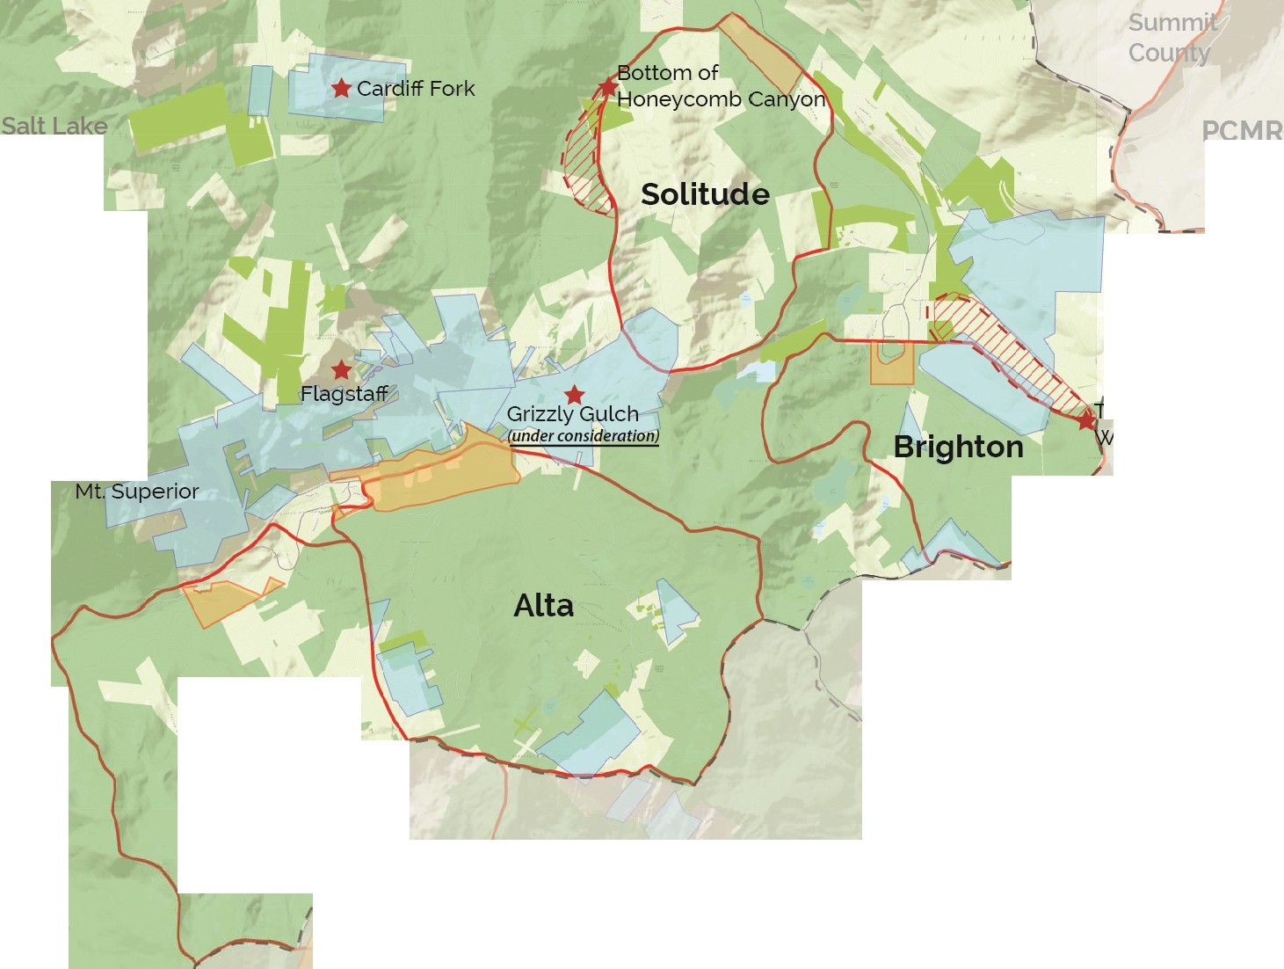
'l

.l
-
-Current Ski Area Boundaries SLC Watershed Parcels Proposed Ski Area Expansion USFS Ownership

Private Lands Under Consideration to become Public Public Lands Under Consideration to become Private

Figure 1:Cottonwood Taskforce Recommendation

Page 3 of 9

General Conditions: The recommendation is subject to the following general conditions:
1. General negotiated options will be presented to the executive committee, who will then offer the negotiated outcomes to the public for comment.
2. Parties will advocate for these outcomes publicly and within their constituencies.
3. Ongoing negotiations on conditions, alignments, and maintenance are expected.
4. Negotiated outcomes are subject to public review and comment, funding, environmental review including NEPA, and critical sequencing details to be defined fully at a later date.
5. Lands exchanged to public ownership will remain open for consideration of recreation access and a flagship trail network that connects to future transit stations in Big and Little Cottonwood Canyons.
6. Lands placed into to public ownership would not be available for future ski‐area expansions beyond those specified in this recommendation (i.e., Hidden Canyon, Silver Fork). Specific parcel‐by‐parcel protection designations and management will be developed at a later date, and may ultimately include Wilderness or other special federal land designations if the acquiring entity is the US Forest Service, or conservation easements if transferred to a local government agency or conservation organization. Acquiring entities and methods of protection/management TBD. (ALL PARTIES)
7. Parties anticipate seeing growth in year‐round ski‐area use and expressly support responsible recreation infrastructure changes (e.g., lifts, trails, etc.) that respond to changes in demand within the ski areas’ respective US Forest Service Special Use Permit boundaries. These changes would be managed through standard permit processes, with the condition that new lifts providing mechanized access to areas outside of resort boundaries will not be planned.
8. Salt Lake City’s, Salt Lake County’s, and Town of Alta’s support of a train and tunnel and provision of additional water, would be conditional
upon widespread levels of new land and watershed protection throughout the municipal watersheds in the Mountain Accord project area , and would be subject to each agency’s Council review and approval.
9. TOA support of increased development potential at Alta Ski Area’s base is subject to Town zoning and land use approvals.
10. These negotiated recommendations, after modified by Executive Board recommendations and public review, would be memorialized in a formal agreement as an addendum to the Mountain Accord Charter, and/or by other suitable means.
11. Land disposals, land‐use adjustments, and water provision would be pursued immediately, while transit review and other permitting
processes are pursued through public processes. Land exchanges with the US Forest Service would be pursued legislatively to simplify processes and expedite. (ALL PARTIES)
12. Trail system investments would be made to improve the variety of activities accessible from base areas in the summer. (ALL PARTIES)
13. Tools (Funds, resources, and/or authorities for fees) are provided to assist with year‐round recreation management to provide safety,
security, visitor services, and resource protection for current and increasing use levels. This would include long‐term and sustainable programming and management resources to reduce human impacts, manage sanitary conditions, mitigate erosion and compaction, mitigate weeds, and address watershed, wetland and riparian, and alpine ecosystem degradation in developed and dispersed areas. (ALL PARTIES)

Unresolved Negotiation Point: Final resolution regarding the Grizzly Gulch area has not yet been achieved. Alta Ski Area desires an opportunity for ski‐area expansion to address growth, and had programmed Grizzly Gulch to accommodate this opportunity. Other parties consider Grizzly Gulch to be central to environmental and backcountry preservation objectives. Parties continue work to resolve this question while considering concepts that may help achieve mutually desirable outcomes. The CCTF anticipates that a solution will be identified and achieved.
However, finalizing this overall recommendation depends upon achieving agreeable consensus on the long‐term use, ownership, and protection of Grizzly Gulch.

Detailed Negotiation Summary:

Landholder Proposed Terms and Conditions
Alta Lands Alta Offers:

1. Multiple parcels (approximately 600 acres) within and just outside ski area boundary.

Alta Desires:

1. Up to 160 acres at base area from USFS. Acreage modification would be determined after further analysis and discussion to reflect the precise needed base area acreage.
2. Special interest and government support for Alta Train station and transit solution addressing the Canyon’s high avalanche danger.
3. A dispersed user trailhead and bathroom facilities that would be constructed on the base‐area land obtained in the exchange.
4. Zoning and new water to accommodate station‐area development (up to 8 restaurant/ commercial spaces and 100 hotel rooms).
5. SLC increases water dedicated to Alta Ski Area for snowmaking from 40MG to 80MG and supports increased reservoir capacity.

Conditions (PARTY):

1. Train alignment analysis will consider multiple alignments, with one specifically including the option for minor changes to Lone Peak
Wilderness boundary. This option would be considered in a subsequent NEPA and/or other public process. (ALTA, SNOWBIRD, TOA)
2. Land development occurring in relation to culinary water provision would be primarily focused around a transit stop. This development footprint area would be approximately 25 acres in size. Other minor development needs would be expected over time within the new base area acreage.
3. A TDR program for Albion Basin may be considered at a future date. (SLC, TOA)
4. A ski lift option on Flagstaff would be eliminated upon installation of an acceptable alternate avalanche control program replacing artillery in the area (SLC, SLCO, SOC, OIND, TOA, ALTA)
5. In relation to lands in American Fork, the AF Vision and USFS public processes for ski‐area boundary and land adjustments are not
within the geographic scope of Mountain Accord. (USFS)
6. Final negotiation of Grizzly Gulch and ski‐area permit boundary expansion questions will achieve agreeable consensus with all parties.

Brighton Lands | Brighton Offers:  1. Multiple parcels (approximately 200 acres) within and just outside ski area boundary.  Brighton Desires:  1. Approximately 35 acres in the base area from USFS.  2. Special interest and government support for Brighton train station and associated developments.  3. Additional water from SLC for snow‐making (amount TBD).  4. Water for station development with up to 4 restaurant/retail spaces and up to 60 total rooms.  5. Ski‐area expansion of approximately 140 acres to include the north‐facing side of Hidden Canyon.  Conditions (PARTY):  1. Hidden canyon expansion would be subject to public acquisition of lands within the adjusted boundary. Prior to expansion, Brighton would be allowed to clean up beetle kill conditions on these lands. (BRIGHTON, FS)  2. Any future lift servicing Hidden Canyon would be designed to return recreationists to the Great Western lift area.  3. Future development would replace Brighton’s existing hotel development and Crest Lodge. (BRIGHTON)
Snowbird  Lands | Snowbird Offers:  1. Multiple parcels (approximately 1,107 acres) including White Pine, Superior/Flagstaff, and Days Fork/Cardiff.  Snowbird Desires:  1. 43 acres of USFS land at base area within the existing service boundary.  2. Special interest and government support for Snowbird train station and associated developments.  3. Three parcels (approximately 289, 93, 34 acres) in American Fork Canyon, and special interest and local government support for expansion of resort boundary and lift systems onto USFS land in American Fork.  4. Additional water from SLC for snowmaking (amount TBD).  Conditions (PARTY):  1. Future Upper Mineral Basin and Mary Ellen Gulch expansion, if proposed, would exclude hotel and condominium development.  Parties acknowledge that Snowbird has expressed interest in facility development to support operations in these areas. Conceptually, these facility developments would be serviced with onsite/self‐contained water and septic to avoid the establishment of significant new infrastructure. Further down AF canyon, other facilities may be proposed. All of these considerations, interests, and proposals would be subject to future decisionmaking and public processes outside of Mountain Accord. (SNOWBIRD; SOC)

2. In the expanded LCC Snowbird Base Area, a “resort zone” would be developed to better define and control development to ensure
the best outcomes with respect to sensitive lands. (SNOWBIRD, SLC, SLCO, SOC)
3. Right to perform avalanche safety control (especially above Snowbird and TOA) is preserved. (SNOWBIRD, TOA)
4. In relation to lands in American Fork, the AF Vision and USFS public processes for ski‐area boundary and land adjustments are not within the geographic scope of Mountain Accord. (USFS)
Solitude Lands | Solitude Offers:  1. 240 Acres in upper Big Cottonwood Canyon/Hidden Canyon/Guardsman Road area.  2. To provide specific backcountry recreationist parking facilities and access near the base of Silver Fork  Solitude Desires:  1. Up to 50 acres (TBD) at the base area from USFS.  2. Special interest and government support for Solitude train station and associated developments.  3. Improved ski‐run or ski‐lift connections between Brighton and Solitude.  4. Shift base of Honeycomb Return lift to confluence of Silver Fork and Honeycomb canyons.  5. Ski‐area permit expansion of up to 70 acres to include the lower portion of the west‐facing slope of Silver Fork.  6. Additional water from SLC for snow‐making (amount TBD).  7. Flexibility from SLC/SLCO in terms of where Solitude places its remaining 150 development units depending upon what transit result occurs; sewer and water units can be moved within the resort’s base‐area to accommodate better development patterns.  Conditions (PARTY):  1. Federal designations protect current dispersed recreation uses and watershed values, and limit the potential for further ski area expansion in Silver Fork. (SLC, SLCO, SOC, OIND)  2. Uphill access through the new resort boundary at the mouth of Silver Fork Canyon to backcountry areas up Silver Fork would not be inhibited.  3. Formal permission to use SLC’s watershed parcels would be obtained if those properties are traversed or contained in Solitude’s expansion.
Salt Lake City  Lands and  Resources | Salt Lake City Offers:  1. Formal permission to use SLC’s watershed parcels where they are traversed.  2. Provision of water to the various Ski Areas for snowmaking purposes (Amounts TBD).  3. Culinary water, as described for each ski area.

Salt Lake City Desires:

1. Widespread levels of new land and watershed protection in the municipal watersheds in the Mountain Accord project area.
2. Land or conservation easement title and/or protective federal land designations on lands offered to the public by the Ski
Areas.

Conditions:

1. Salt Lake City decisions regarding land use, water contract, and watershed permissions are subject to legal review and City Council review and approval.
Forest Service  and Other  Public Lands | USFS desires to consolidate NFS lands, obtain inholdings, and to release ski base‐area lands in NFS in exchange for minimally or  undeveloped lands. USFS agrees to analyze and potentially implement, through NEPA and public process, the following land exchange concept:  The USFS and/or appropriate local government agencies receive for public purposes the following approximate acreages of lands containing upper watershed ecosystems and habitat, backcountry terrain and access, and scenic/iconic landscapes:  1. 600 acres of upper mountain lands from Alta. (Grizzly Gulch portion still under consideration as an unresolved negotiation point.)  2. 1,107 acres of upper mountain lands from Snowbird.  3. 200 acres of upper mountain lands from Brighton.  4. 240 acres of upper mountain lands from Solitude (property is offsite near Brighton).  Land the USFS gives (approximately):  1. Snowbird: Base area lands (43 acres) and AF Canyon lands (416 acres with possible ski‐area permit expansion, subject to American  Fork & Utah County planning processes and public review).  2. Alta: Base area lands (160 acres); Possible ski‐area permit expansion (expansion concepts still under consideration as an unresolved negotiation point.)  3. Brighton: Base area lands (35 acres); Ski‐area permit expansion into Hidden Canyon.  4. Solitude: Base area lands (50 acres); Ski‐area permit expansion to include the ridge between lower Honeycomb Canyon and lower  Silver Fork.  Conditions (PARTY):  1. Primary consideration for NFS lands in the Tri‐Canyon area are for watershed protection and enhancement (2003 WC Forest Plan).

2. Land transactions will be subject to recommendations and mitigations resulting from NEPA process.
3. Land management designations for USFS acquired lands would be consistent with adjacent/surrounding lands, or as otherwise recommended through Mountain Accord. (USFS)
4. Ski areas further assist with providing and managing year‐round recreation opportunities. (USFS)
5. Allocations of quality backcountry/dispersed recreation opportunities remain within the mix of land allocation. (USFS)
6. Ski area expansions or land transactions should not reduce the allocation of quality dispersed recreation opportunities (2003 WC
Forest Plan). In addition, these transactions cannot be done without analyzing the effects to other current permitted uses such as
Utah Mountain Adventures, Wasatch Powderbird Guides, Ski Interconnect, etc . (USFS)
7. Capacity controls need to be developed, implemented, and enforced with more people being transported more efficiently into the area. Effects to watershed, Wilderness, and resource values need to be analyzed and mitigated. (USFS)

